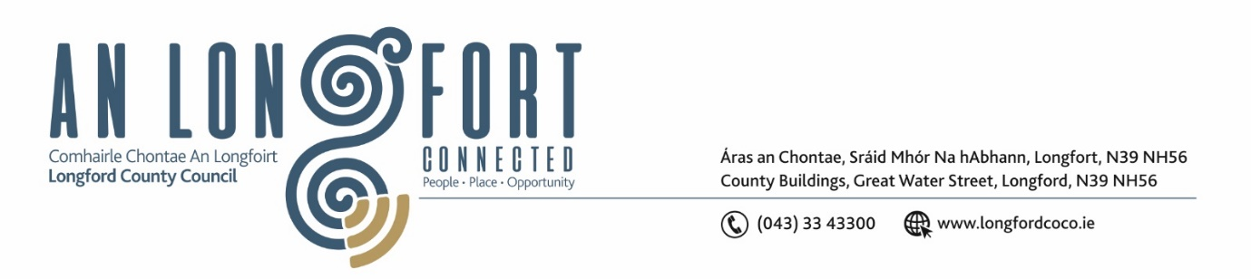

***Please note meeting will be held in the Council Chamber and via Microsoft Teams.***

2 Bealtaine 2023

**Chuig: Gach Ball don Chomhairle**

A Chomhairleoir,

Iarrtar ort bheith i láthair ag Cruinniú Míosuil Chomhairle Chontae Longfoirt a tionólfar i Seomra na Comhairle, Aras an Chontae, Longford agus via MS Teams are an **Chéadaoin 10ú Bealtaine 2023 ag** **3.30pm** chun gnó a dhéanamh d’réir an Chláir thíos.

You are requested to attend the Monthly Meeting of Longford County Council to be held in the **Council Chamber and via Microsoft Teams** on **Wednesday 10 May 2023 at 3.30pm** to transact business, as set out on the Agenda hereunder.

Mise le meas,

**__________________**

***Claire McNabola***

***Meetings Administrator.***

**C L Á R**

Prayer before meeting.

Presentation on Just Transition from representative of Failte Ireland.

**1.** Confirmation of Minutes of Monthly Meeting of Longford County Council held on 12 April 2023 – enclosed.

**2.** Matters Arising.

**3.** Declaration of Interest by Members.

**4.** To note Management Report – to follow.

**5.** To note adopted Minutes of Corporate Policy Group Meeting held on the

11 March 2023 – enclosed.

**6. Community,** **Library and Cultural Services, Corporate and Human Resources**

**(a)** Community Grant Support Scheme 2023 – Intercultural applications

**(b)** Notice of Motions, submitted by Councillors, as listed hereunder

**Councillor Paul Ross**

I call on Longford Co Council to explore the Cultural, Educational and Business links between Co Longford and San Francisco in light of the recent remarks made by Vice President Kamala Harris when she referenced Longford Native Frank McCoppin as the first ever Irish Mayor of a major city in the USA in 1867 in her St Patricks weekend speech.

**Councillor** **Uruemu Adejinmi**

1. I call on Longford County Council to have an ISL interpreter present at Council meetings to make meetings accessible to a wider audience viewing the meeting online or in person.
2. I call on Longford County Council to create a County Registry for defibrillators on Longford County Council website and invite Community Groups, Clubs and Local Organisations to register their defibrillators.

**7. Infrastructure, Climate Action and Innovation**

**(a)** To note adopted Minutes of the Climate Action and Planning Strategic Policy Committee held on 1 February 2023 - enclosed

**8. Finance and Information Technology**

1. To note adopted Minutes of meeting of Governance Strategic Policy Committee held on 31 January 2023 – enclosed
2. To note 2022 Audit Committee Annual Report
3. Consideration of Annual Financial Statement for Year ended 31 December 2022 – hard copy by post
4. Consideration of Approval of Additional Expenditure under S104(7) of the Local Government Act 2001
5. Longford Dream Space Showcase – Update

**9. Housing, Planning, Regeneration & Capital Projects**

1. To note Planning Applications received since last meeting of the Council.
2. To note adopted Minutes of meeting of Strategic Infrastructure Strategic Policy Committee held on 2 February 2023 – enclosed
3. Items referred from Strategic Infrastructure Strategic Policy Committee meeting held on 17 April 2023:

**(i)** Consideration and adoption of Roadside Memorial Policy – enclosed

**(ii)** Consideration and adoption of Local Road Safety Plan 2022-2024 - enclosed

1. Consideration of disposal of Property at Gaigue, Ballinamuck, Co. Longford in accordance with the terms of Section 183 of the Local Government Act 2001 issued on the 11 April 2023 – as circulated.

**10. General**

1. Notice of Motions, submitted by Councillors, as listed hereunder:

**Councillor Garry Murtagh**

Calling on Longford County Council to write to the Minister for Health Stephen Donnelly, in relation to insufficient support through the HSE for Home Help and it's failings to replace HSE retirees. This invaluable service is at breaking point.

Private operators are failing to prop up this system due to min wage and minimal and insulting subsidies for travel which makes it financially not viable for them to continue in their role. Due to the lack of service/care people are afraid to leave hospital, blocking up hospital beds and forcing people into nursing homes. Further more it is not financially viable for them nor the state, for our elderly not to have the option to stay in their own homes.

**11.**  **Correspondence**

1. Correspondence received on 21 April 2023 from Department of Agriculture re. stimulus package for the sheep sector.
2. Correspondence received on 20 April 2023 from Department of Finance re. construction workers PAYE.
3. Correspondence received on 19 April 2023 from Office of the Garda Commissioner re. Garda Vetting.
4. Correspondence received on 2 May 2023 from Department of Rural and Community Development re. shop local scheme.

**12. Training – enclosed.**

**13. Votes of Sympathy**